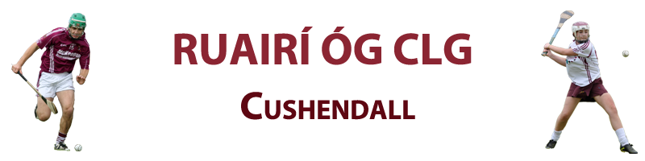
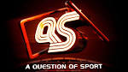
Entry fee is £10 and prizes are as follows: 1st - £350, 2nd £100 and 3rd £50.
In the event of more than 1 person scoring the same number of points, names will be drawn at random with the 1st name out getting the top prize that is applicable and so on to the 3 prizes are won. Committee’s decision is final. All entries must be in and paid by 10 February 2017.
^{Question - ‘WHO WILL WIN’} | ^{Answer}
National Hurling League Division 1?
National Football League Division 1?
The Ulster Football Championship?
The Munster Hurling Championship?
All Ireland U21 Hurling Championship?
All Ireland U21 Football Championship?
All Ireland Senior Hurling Championship?
All Ireland Senior Football Championship?
All Ireland Senior Camogie Championship?
^{Six Nations Rugby?}
^{Rugby European Cup?}
^{UEFA Champions League?}
^{UEFA Europa League?}
^{FA Premiership?}
^{The FA Cup?}
Antrim Minor Hurling Championship?
Antrim Minor Football Championship?
Antrim U21 Hurling Championship?
Antrim U21 Football Championship?
Antrim Senior Hurling Championship?
Antrim Senior Football Championship?
^{The Masters Golf?}
^{US Open Golf?}
^{The Open Golf?}
^{PGA Championship Golf?}
^{Formula 1 Championship?}
^{PDC World Darts Championship?}

^{Name: _____________________} ^{Paid:___________________}

